Ch 8: Introduction to Multilevel Modeling

**Case study: Music performance anxiety**

1. Data for this study was collected at two different levels. Higher level (Level 2) variables are attributes of specific musicians; these variables remain constant over all performances. Lower level (Level 1) variables are attributes of specific performances. Classify the following variables (complete list in **MultilevelIntroAug19.Rmd**) as: Level 1 explanatory, Level 2 explanatory, or response:

# previous number of previous dairy entries filled out

# perform_type type of performance (solo, large or small ensemble)

# memory performed from Memory, using Score, or Unspecified

# audience who attended (Instructor, Public, Students, or Juried)

# pa positive affect from PANAS

# na negative affect from PANAS

# age musician age

# gender musician gender

# instrument Voice, Orchestral, or Piano

# years_study number of years studied the instrument

# mpqab absorption subscale from MPQ

# mpqpem positive emotionality composite scale from MPQ

# mpqnem negative emotionality composite scale from MPQ

2. What are pros and cons to performing EDA using a single plot with all 497 observations (one per performance) vs. a single plot with just 37 observations (one per musician, for instance by taking means across performances) vs. 37 different plots (one per musician, with points representing individual performances)?

3. Based on the EDA, what seem to be key factors in performance anxiety?

4. Why is putting all 497 observations into a linear regression model not a good idea? How will you discover issues – R warnings, residual plots, … ?

5. In Table 8.3 in Section 8.5.5 of BYSH (see also below), do the four approaches compare and contrast as you’d expect? Explain. What are pros and cons of each approach?

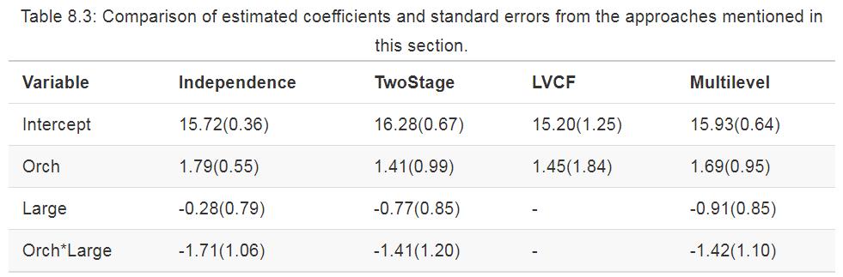

6. Explain the multilevel model from BYSH Section 8.5.1 (see also below) to your partner. Note that $Y_{ij}$ is the negative affect (performance anxiety) score for the *j*th performance of musician *i*. In particular,

* What are the Level 1 and Level 2 variables in this model?
* What does $b_{i}$ mean?
* What does $α_{1}$ mean?
* What does $ϵ_{ij}$ mean?
* What does $u_{i}$ mean?
* What does it mean to assume bivariate normality in errors at Level 2?
* Which terms are fixed effects, which are random effects, and which are variance components?
* How would you implement this in R?

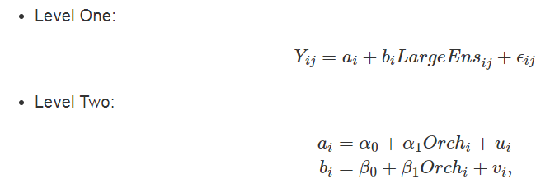

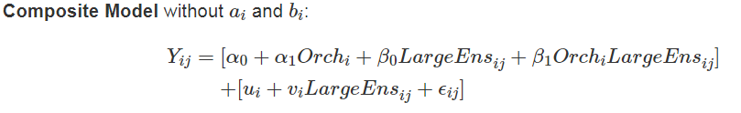



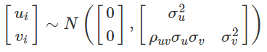

7. Find the estimates of $α_{0}$ in Models A-C (see next page) and compare and contrast their interpretations in context.

8. Find the estimates of $β_{0}$ in Models B-C and compare and contrast their interpretations in context.

9. Find the estimates of $σ_{u}^{2}$ in Models A-C and compare and contrast their interpretations in context.

10. Find the estimates of $β_{1}$ in Model C and provide its interpretation in context.

11. In Model A, we see that the intraclass correlation coefficient is 0.182. What does this tell us about the effective sample size in our data?

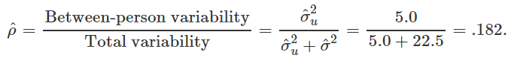

The first three models fit to this data are written out below: A is the unconditional means (random intercepts) model, B is the random slopes and intercepts model, and C adds “orchestral instrument” as a Level 2 covariate.

Model A

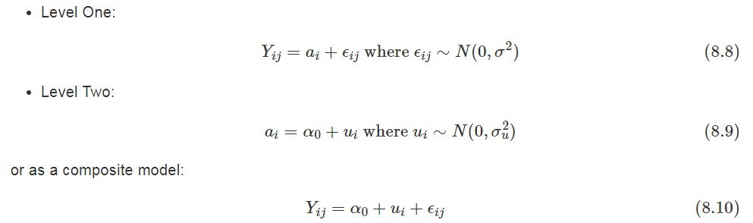

----------------------------------------------------------------------------------------------------------------

Model B

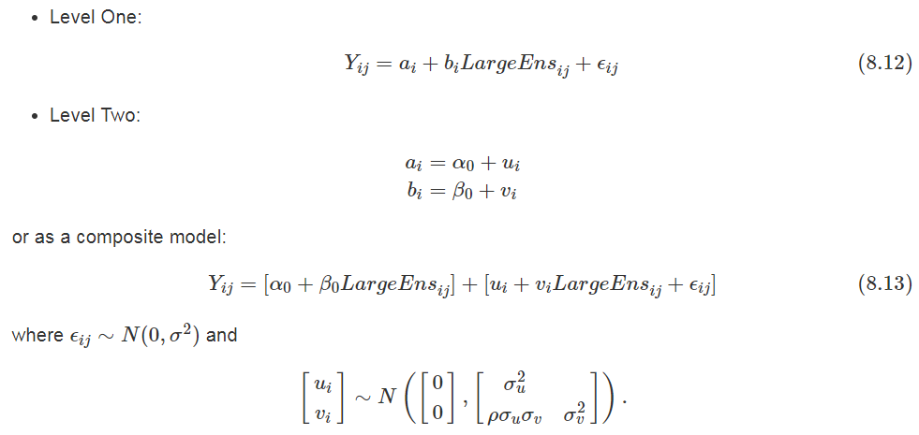

------------------------------------------------------------------------------------------------------------------

Model C

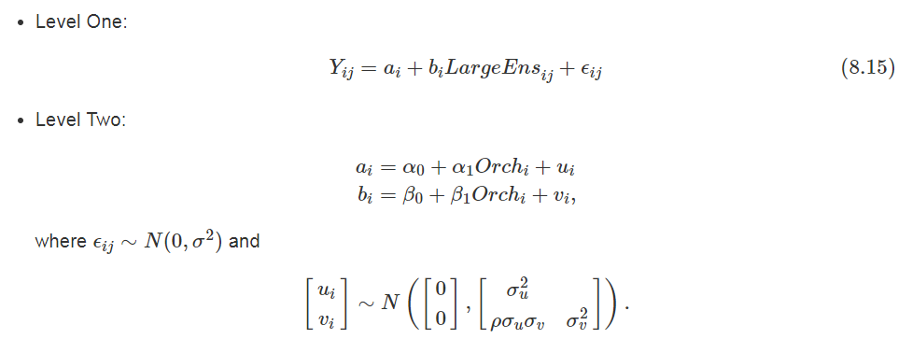

12. How does the “random intercepts” version of Model C differ? Does it lead to similar conclusions as the original Model C? Which model is “better”?

Model D, which adds a second Level 2 covariate to Model C, is written out below. Model E is then the same as Model D except that baseline negative emotionality is centered at its mean.

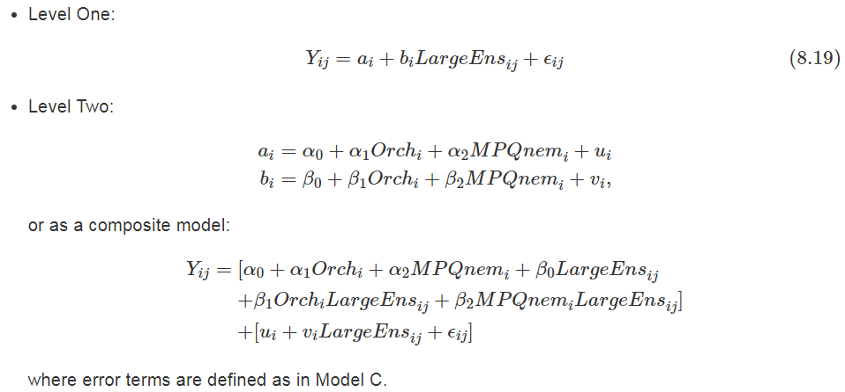

13. Is Model D an improvement over Model C? How did you make your decision?

14. Which parameters (fixed effects or variance components) will change from Model D to E?

15. Find the estimates of in Models C-E and compare and contrast their interpretations in context.

16. Find the estimates of in Models C-E and compare and contrast their interpretations in context.

17. Find the estimates of in Models C-E and compare and contrast their interpretations in context.

18. Model F (below) is one potential final model for this data. Without peeking at BYSH or the R output, state the number of parameters than would need to be estimated in Model F (fixed effects + variance components).

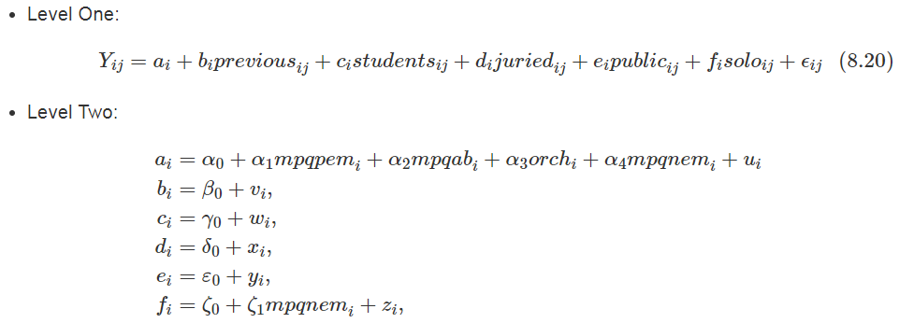

19. Find the estimates of $α_{4}$ and $f_{1}$ in Model F and provide interpretations in context.